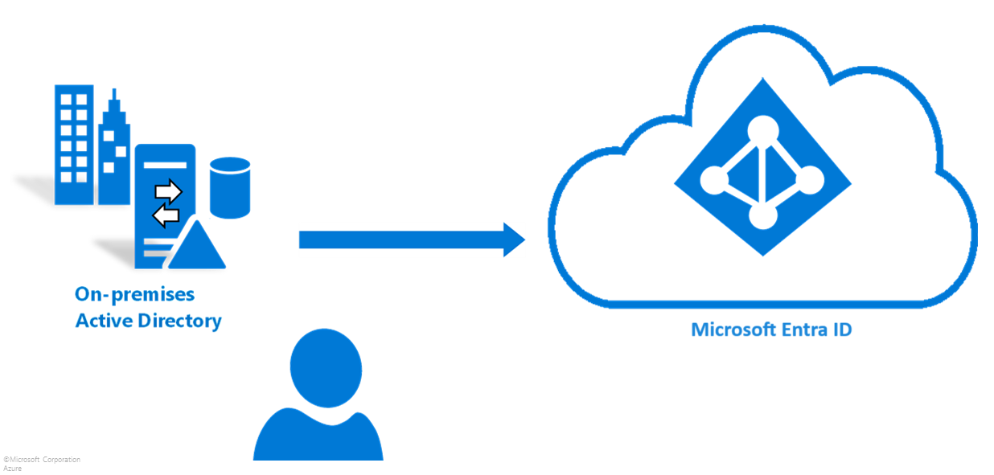

Hybrid M365 Troubleshooting: How to fix HCW Error : "Connect to the Remote ServerFailed.WinRMcannot process the request because the input XML contains a syntax"
___________________________________________________________
Product Name: Microsoft Exchange, Microsoft Entra Connect, Microsoft 365
Version: Entra Connect Sync 2.6.1.0 / Exchange 2019 CU15 /Windows Server
2022 DataCenter
Phase: Deployment
Date: Apr 17, 2026

Step 0 : Error has Occurred
During your company's process to move Users and identities objects to Microsoft Cloud Entra and Microsoft 365 synchronizing services. You run into an error message.
Error: “WinRM cannot process the request because the input XML contains a syntax error.”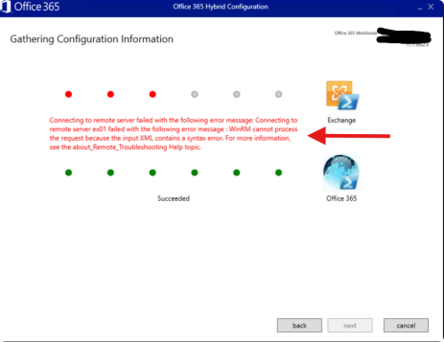
This indicates that the Windows Remote Management (WinRM) service received a malformed or invalid XML payload during request processing, preventing it from parsing and executing the remote command.
We will go through a check-list to double-check a few things to help resolve it:
- Using the Correct Server
- Checking the Windows Server WinRM Service
- Checking the Server Firewall Settings
- Using the proper Administrator Account Credential to resolve the issue
- Restarting thr WinRMService to allow the Hybrid Configuration Wizard to see both On-Prem attributes and Cloud.

Step1: Make sure you are on the correct Server

We want to be sure you run these troubleshooting steps on your "Exchange Server".

First, lets run "Exchange Management Shell" from the "Windows Searchbar"

Wait for it to "Connect" then type this command in the "Management Shell" "Get-ExchangeServer | fl"
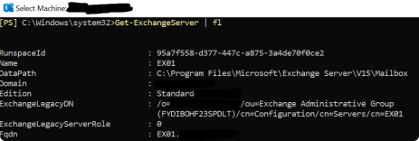
If this is a Virtual Machine make sure your Exchange and your Domain Controller (DC) are "Time Synchronized"
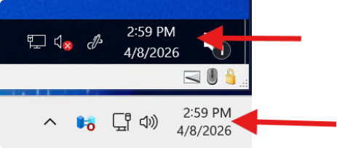Time is Synced

Step 2: Double-Check your Microsoft (Remote-Management Services) are Enabled and Running)
Microsoft’s Remote Management (WinRM) services enable secure remote administration of Windows servers, typically using PowerShell Remoting (ports 5985/5986)
For this error ensuring the WinRM service is running, allows configuring firewall rules to allow traffic, and verifying TrustedHosts for authentication.
Check "Services.msc" and make sure that "Windows Remote Management is Enabled and Running-Automatic DelayStart"
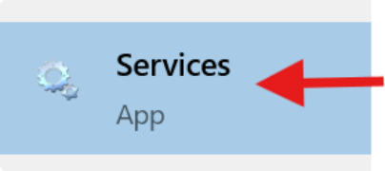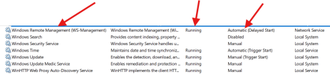Running with Automatic-Delay

Step3: Make sure your "Advanced Windows Firewall Settings" is open for the "WINRM service" to Send and Receive Out of the server Rules
*Since the firewall blocks HTTP/HTTPS traffic (ports 5985/5986) by default, preventing PowerShell Remoting and remote administration.

-Go into “Windows Defender Firewall Settings”
In “Control Panel”

Select from the Left Side-Panel “Advanced Windows Firewall Settings”
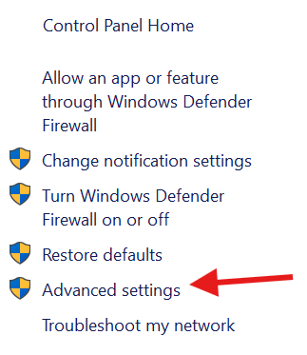
Once on the “Windows Defender Firewall with Advanced Security” Application
Select “Inbound Rules” and Allow these 3 services in your Windows Firewall “Windows Remote Management (HTTP-In)” “Public,Domain,Private” “Allow”
“Windows Remote Management - Compatibility Mode (HTTP-In)” “All”
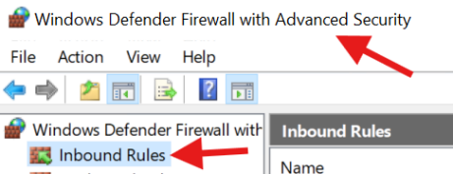
Step4: Ensure your "Exchange Admin" you are installing the HCW with has "Remote Management Users Role" Applied to their Account
*Since HCW relies entirely on Remote PowerShell (WinRM) to execute commands on Exchange servers. Thus, a User needs a Remote Management Users Role.
Go to "Computer Management"

"Local Users and Groups" - "Users"
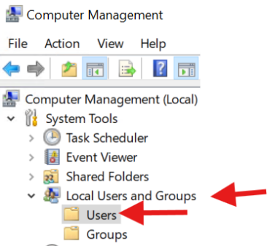
Find the "Exchange Admin" Account Under "Full name"
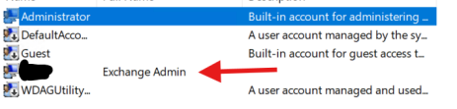

Under the Exchange Admin's "User Properties" Click "Add"
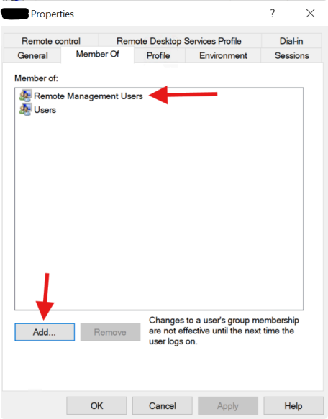
Within Groups Object Type "Remote Management Users"
Then Click "Check Names" - Click "OK"
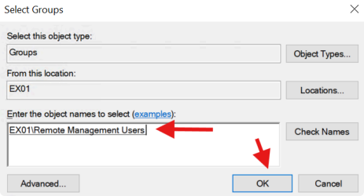
Now that "Remote Management Users" In in the Users Properties Click "Apply" and "OK"

Now our “Exchange Admin Account” is added to the "Remote Management Users Role"

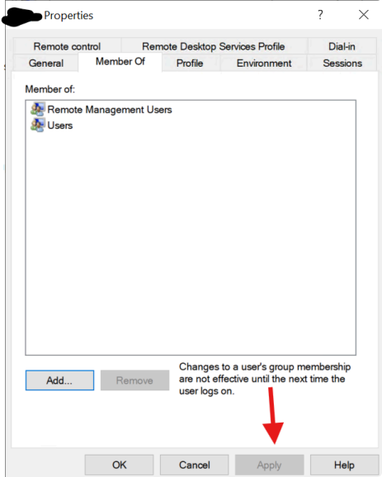

Final Step 5: Restart the WinRM Service with “winrm quickconfig”
The winrm quickconfig command is used to resolve connection failures because it automates the setup of necessary components that are often broken or unconfigured

Go ahead and open "Powershell as Admin" and check the WinRM service Restarts with this command: "winrm quickconfig"

Next, configure "TrustedHost" with the following commands :
"Set-Item WSMan:\localhost\Client\TrustedHosts -Value 'TheRemoteHostsIpAddress' - Concatenate"
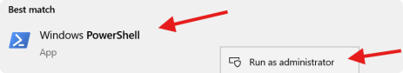
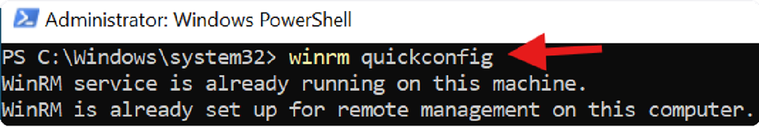
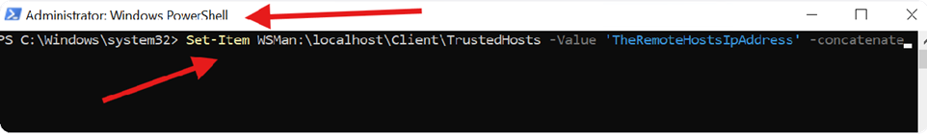Why is this used in your HCW / Exchange scenario? These commands configure Windows Remote Management (WinRM) to trust a remote computer for PowerShell remoting connections, even if that computer is not part of a trusted domain or properly authenticated via Kerberos
In Hybrid Exchange / M365 setups, this is sometimes used when:
- WinRM remote PowerShell cannot establish a trusted session
- Kerberos authentication is not possible (workgroup, misconfigured domain, trust, or name resolution issues)
- HCW or Entra Connect needs temporary remote access validation

Now Re-run the HCW Install Application again and "Gathering Configuration Information"
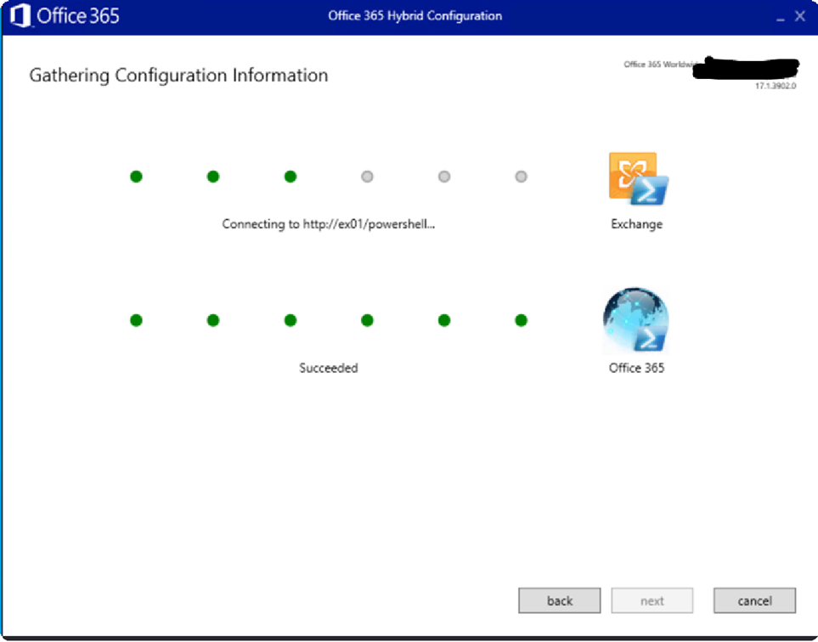

Now, the issue has been resolved.
Click "Next" and continue installing your "Hybrid Exchange Server"
